A Life in Ice: Glacier Ice Worms
Mauri Pelto, Nichols College, Dudley, MA 01571
As we move through natural areas we often have to be careful of where we tread to not crush some living organism. No one would expect this to be the case on a glacier. After all how can a permanently frozen landform host life? Invariably when people first here of ice worms, they think you are kidding, myself included. However, ice worms really do live in glaciers, in fact, ice worms can't live off of them!
Many people who venture onto glaciers have not seen these organisms. That is because their known range is limited to portions of the Cascades and the Coastal Ranges of British Columbia and Alaska. Of equal importance they do not tolerate even diffuse solar radiation and typically can be seen only when the sun cannot. Most hikers do not venture onto glaciers after sunset or before sunrise.
Their scientific name is Mesenchytraeus solifugus (Emery, 1898). They are about 1 cm (1/4") long, and about 1 mm (1/32") wide. Glacier ice worms are dark brown to black and when you see them on the glacier, they appear as loose pieces of string in the snow or ice. These ice worms are in the class of Oligochates and family of Enchytraeidae, just like earthworms, and are members of Annelida, or segmented worms. There are other worms called 'ice worms' that live in methane hydrate ice on the ocean floor, or deep underground, but they are unrelated to glacier ice worms.
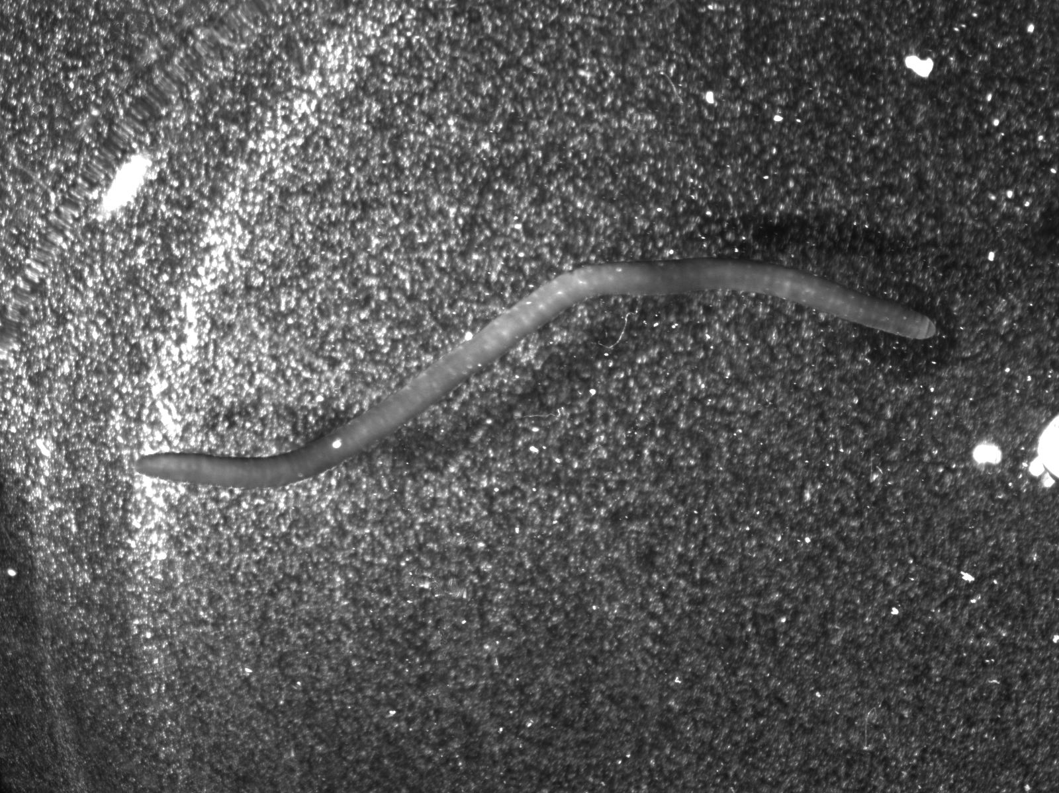
Glacier ice worms manage to not freeze by retreating within the snowpack when temperatures are low. They appear on the surface mostly at sunset, and by sunrise most have already retreated into the glacier, possibly to avoid the cool nighttime temperatures. The exception is ice worms that live on the glacier ice in pools of water. This illustrates another difference with ordinary earth worms which we have all seen drowning even in a small puddle. Ice worms are often sighted in the glacier meltwater pools, slush, and streams found in or on top of glacier ice, even during the day. It is believed that the water filters the longwave radiation sufficiently for the ice worms to hang out there during bright periods. Ice worms feed in pools and streams, keeping one end hooked in the ice while the other end (apparently the mouth) waves back and forth in the water.
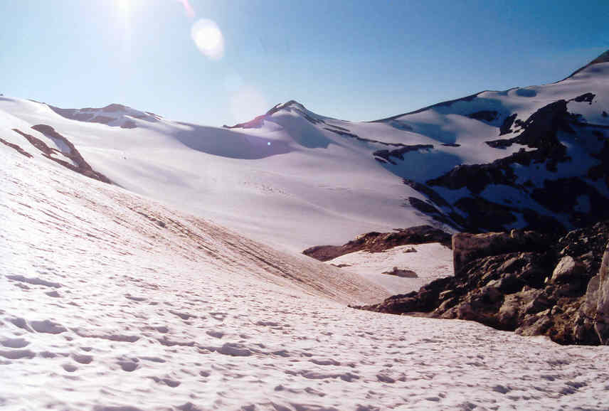
It is hard to step in the evening onto the snowpack of a North Cascade glaciers without squashing an ice worm. They are the keystone species of this ecosystem. On an August evening in 2002 while traversing the Suiattle Glacier (below), on the south side of Glacier Peak, we stopped every one hundred meters to sample the ice worm population, counting every worm inside a .3 square meter grid. The mean density was ~2600 ice worms per square meter, that is 50-75 ice worms in the area of a footprint. With an area of 2.7 square kilometers, this represents somewhat over 7 BILLION ice worms on this glacier! This is more than the earth's entire human population, on just one glacier. Good thing they do not use much natural resources each.
Glacier ice worms inhabit glaciers from southern Alaska's coastal ranges through the Coast Ranges of British Columbia, the Cascades of Washington to the Three Sisters of Oregon. It was thought that there range was limited to the area of the Cordilleran Ice Sheet that covered the Pacific Northwest 21,000 to 14,000 years ago. However, this ice sheet never reached the Columbia River. Yet, ice worms thrive on the glaciers of the Three Sisters in Oregon. It is also noteworthy that ice worms are not found in the interior ranges of British Columbia (Bugaboos, Selkirk, Monashee) or in the Rocky Mountains, which was the interior side of the Cordilleran Ice Sheet. The ice worms seem to be associated only with temperate climates, the interior locations have colder temperatures that can freeze all of the liquid water in the glacier. The coastal glaciers seldom if ever experience sustained cold temperatures that can freeze all of the liquid water. Given their small size the ice worms cannot disperse from one mountain to another across an ice free zone. Ice worms die at temperatures much more than 10º C, and begin to decompose at temperatures above 20º C. This limits the dispersal method to birds, which are famous for dispersing fish through the high country too.
In 2003 we sat at the edge of the Sholes Glacier looking at the glacier covered Mt. Baker volcano waiting for the sun to set. After sunset we counted the ice worms on the glacier. There were close to 1000 per square meter right to the glacier margin. Because of tremendous snowfall in 1999 and 2000 a substantial snowpack extended over the ridge at the edge of the glacier. By the time we had traveled 10 meters from the edge of the glacier onto this snowpack almost no ice worms existed on the snowpack, within 30 m we could not find a single ice worm. This is true even in cases where the snowpack adjacent to the glacier survived the summer. Thus, ice worms seem to require the multi-year glacier ice for survival. Thus, glacier ice worms serve as an excellent indicator of the presence of a glacier below the snow. This suggests that in the course of their daily vertical migrations they are able to sense when they venture into a region of thin snowpack, as well that glacier ice is critical for ice worm survival. What the exact tie is between ice worms and the glacier, we have yet to find out.
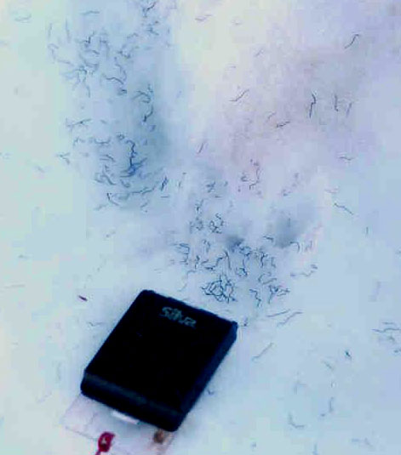 | 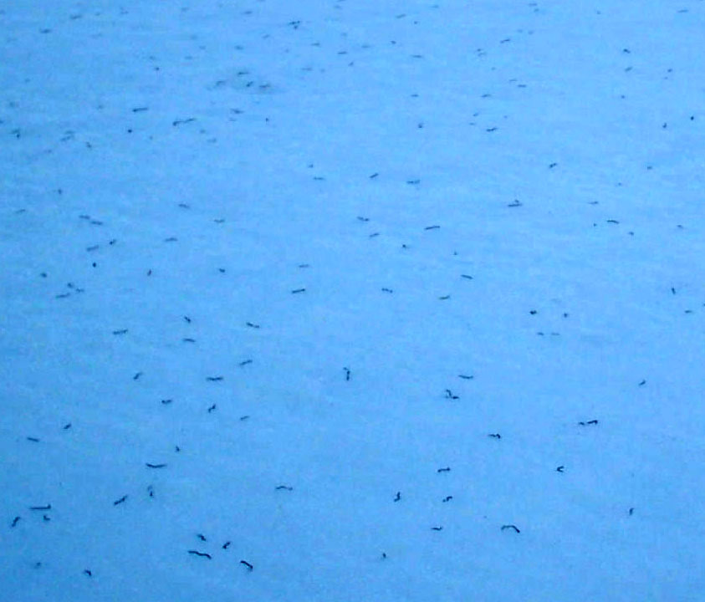

They do eat snow algae, which is available in great quantity in the snow, not limited to the stuff we see as 'watermelon snow'. Ice worms graze on algae in the snow, as well as bacteria and anything else that is small enough to fit in their mouths (which are tiny indeed). When Goodman dissected ice worms from Alaska, he found symbiotic single-celled creatures residing there; these warrant further investigation. Because there is so much algae and so many ice worms, their role in downstream ecology is probably very significant, both in terms of biomass, and in terms of carbon and other nutrient processing. Algae is ubiquitous and thus it easy to imagine algae eating worms that would adapt to ice when an ice age occurred.
Equally important, ice worms cannot migrate from glacier to glacier, so that populations are isolated from each other. These populations offer a unique opportunity for testing rates and mechanisms of evolution. This is why we collected species from glaciers all over the region. The DNA sequencing, completed by Paula Hartzell, Clark University has not yet yielded definitive answers.
Ice worms avoid direct sunlight, so you will be less likely to see them during the day. They rise to the snow surface on glaciers as the surface becomes shady in the evening. As shown in the table below, they begin to come out after 3pm, depending on the shadiness of the location and the time of year. (The fact that there are no ice worms recorded after 8pm and before 7 am is because we weren't looking then.) Look for ice worms first in the shade created by suncups; later in the evening you will see them virtually cover the surface of glaciers in the North Cascades; they are more patchily dispersed on Alaskan glaciers. Ice worms often occur at densities of 2000 or more per square meter on North Cascades glaciers! They are reported on Alaskan glaciers to occur at densities of 100 to 200 per square meter.
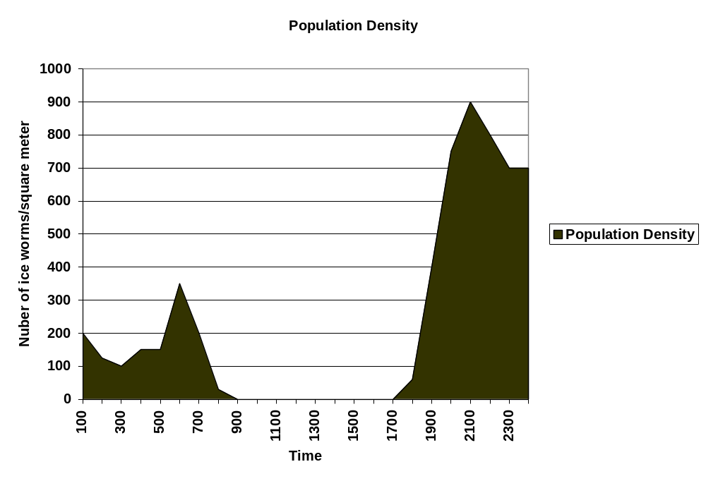
Table 1 highlights the change in ice worm population on Columbia Glacier, WA through the day and night.
In still pools, ice worms can be found at extremely high densities either relaxing in muddy sediment on the bottom, or wrapped together in tight, twisting bundles of several to 100+ worms. This bundling activity is probably part of their reproductive cycle, as has been reported for other oligochates. The pool shown in the photo had more than a dozen such writhing bundles on the muddy bottom.
Ice worms have curiously few features which appear adapted to their icy habitat. They have the same basic physical structures as earthworms, with few obvious morphological changes. They are similarly segmented, have bundles of setae (hairs) along the bottom for moving, and a mouthpore at one end (see photos below). As members of the order Enchytraidae, they also have very distinctive penial lobes, which, don't really remind most of us of male genital organs. Perhaps most striking is their dark color, with more melanocytes by far than any other worm; this is obviously an adaptation to protect them from intense UV exposure.
The current rapid retreat of glaciers within the ice worms range is certainly reducing their population. This retreat however, is another story.
The traditional (morphology-based) classification for glacier worms is as follows:
Kingdom: Animalia
Phylum: Annelida
Class: Clitellata
Subclass: Oligochaeta
Order: Haplotaxida
Suborder: Tubificina
Family: Enchytraeidae
Genus: Mesenchytraeus
Species: solifugus
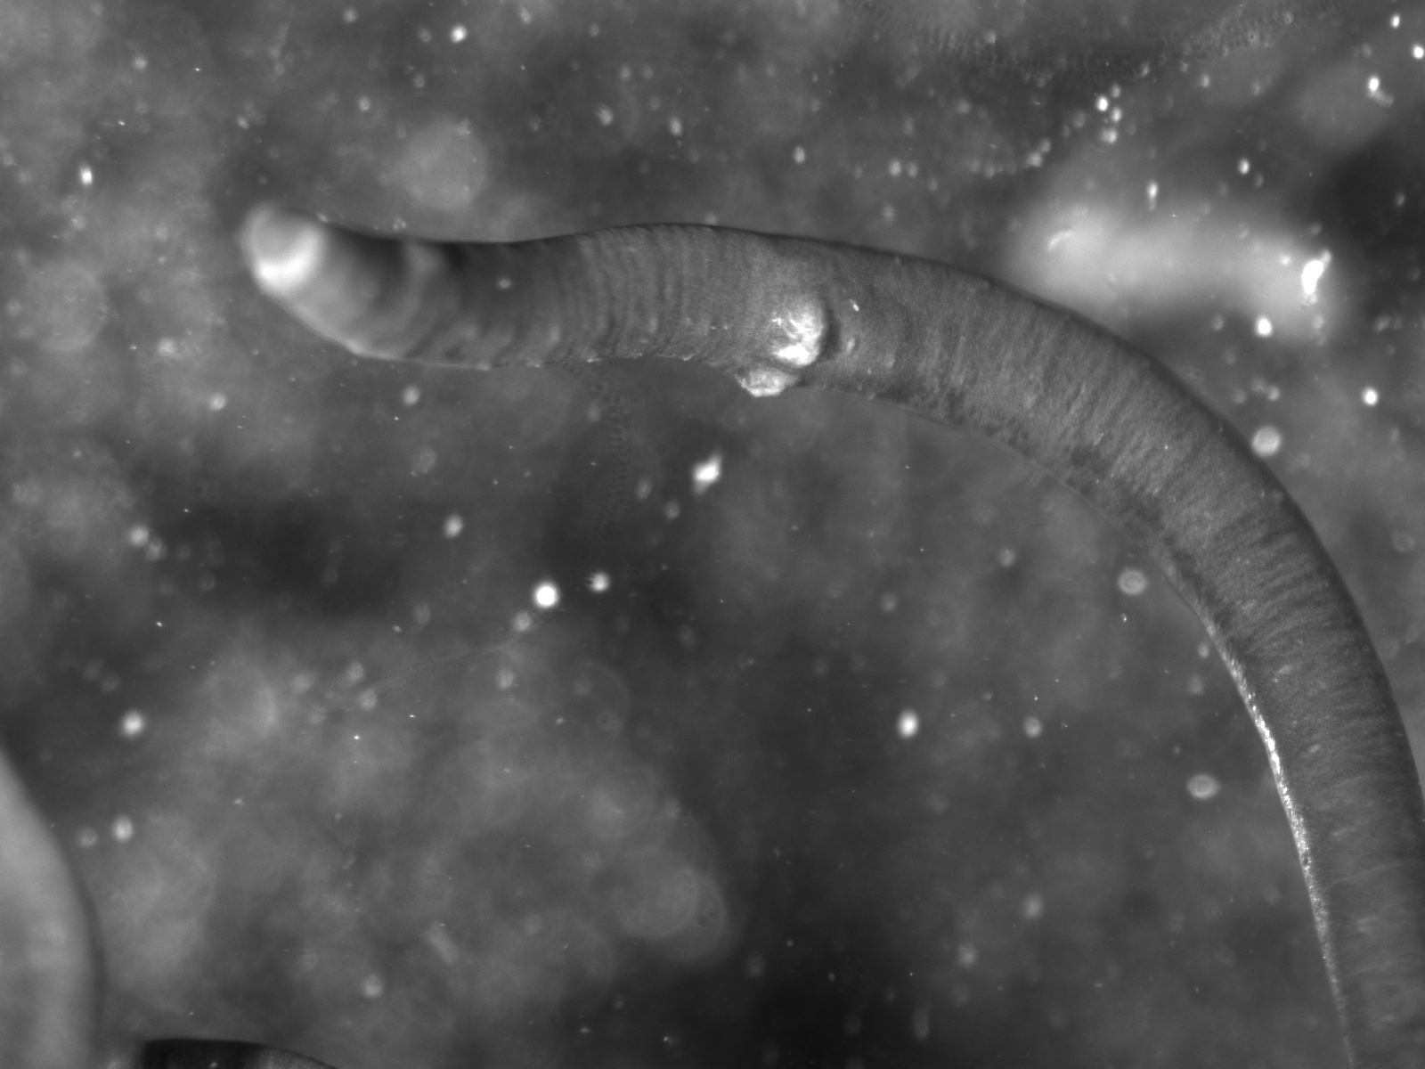
DNA analysis is being completed to determine more specifically how ice worms fit into the Haplotaxida order and who their closest relatives are within Oligochaeta..

